Australia

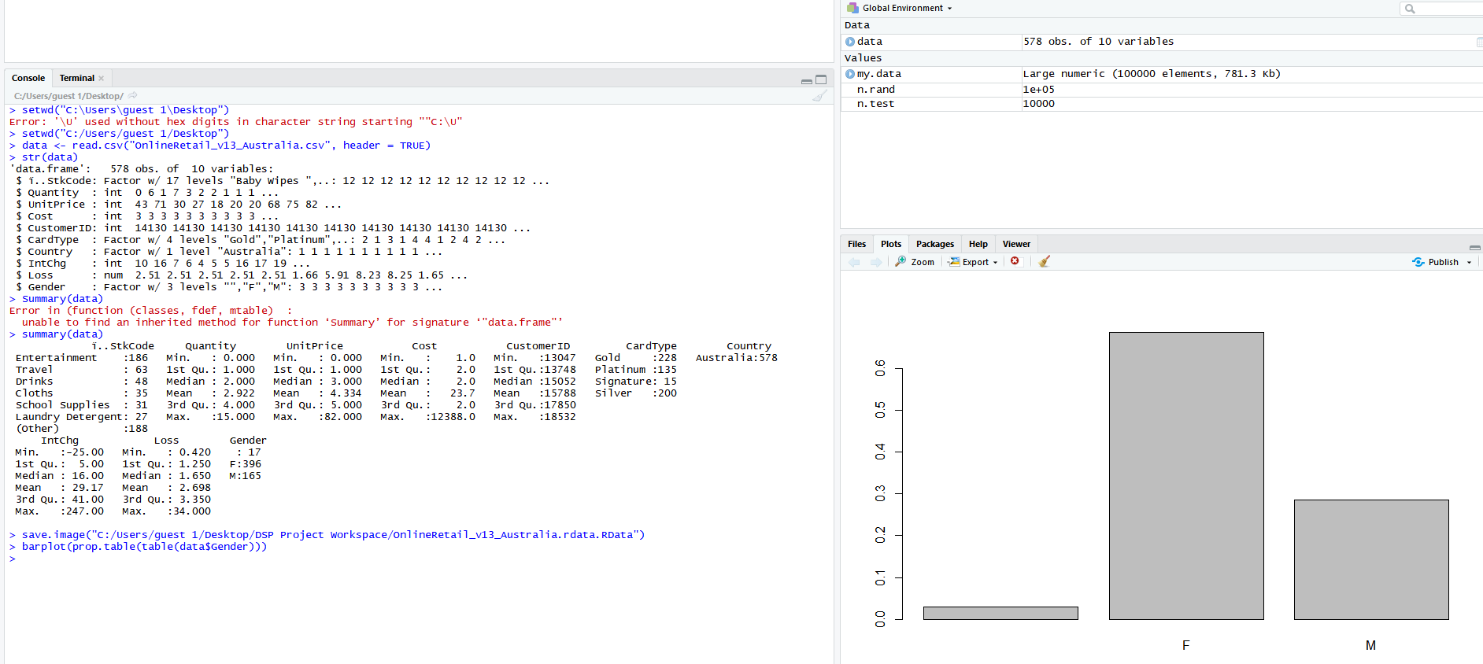

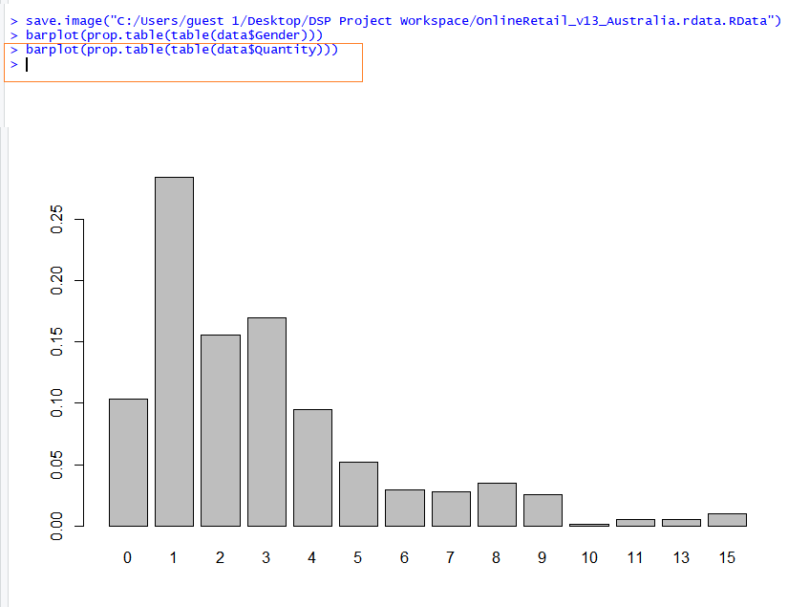

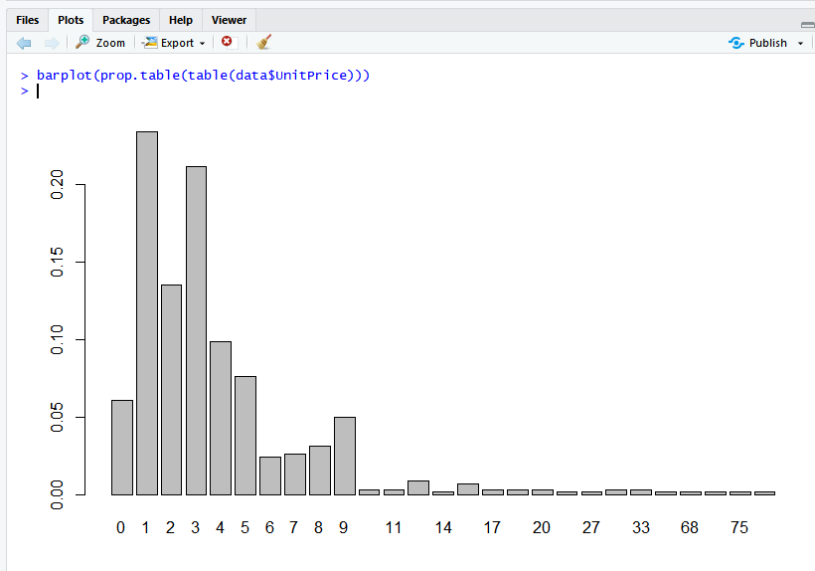

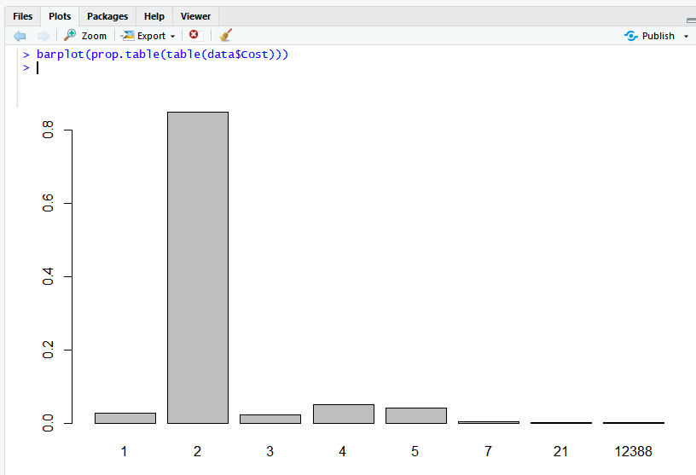

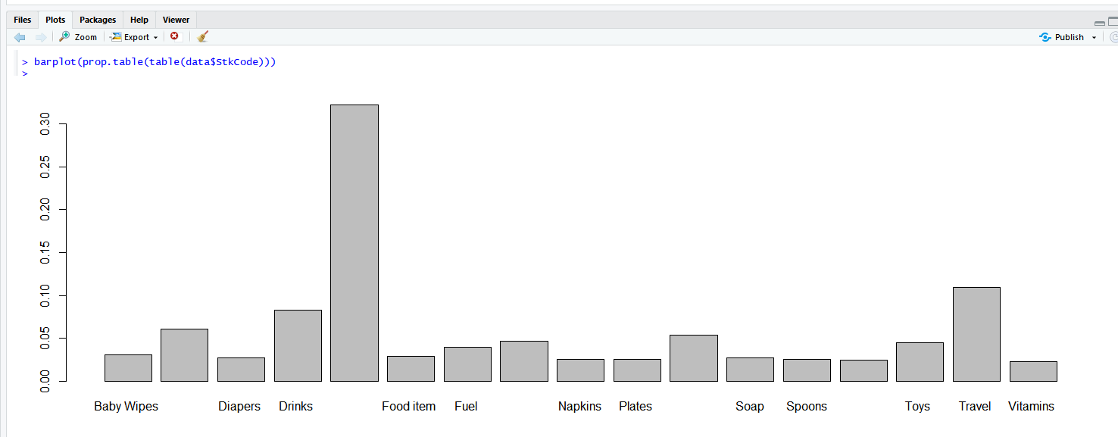

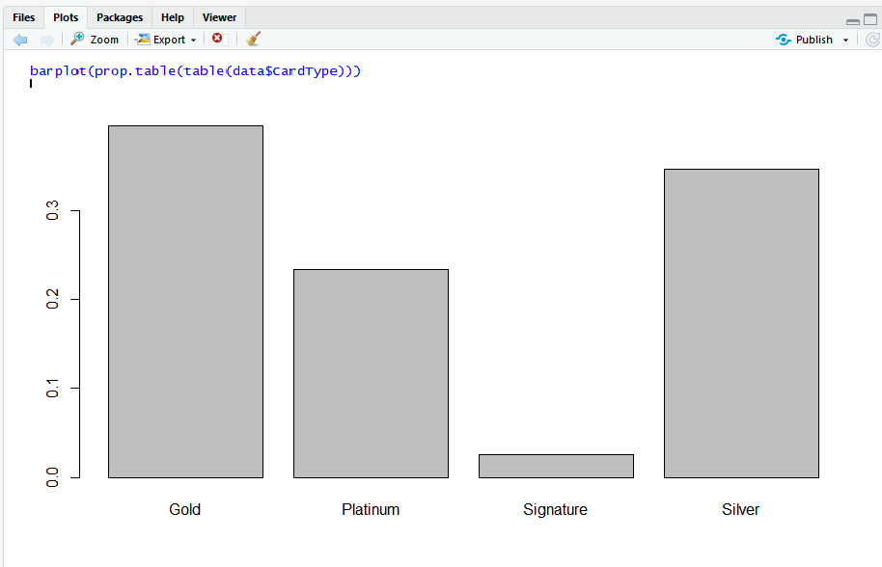

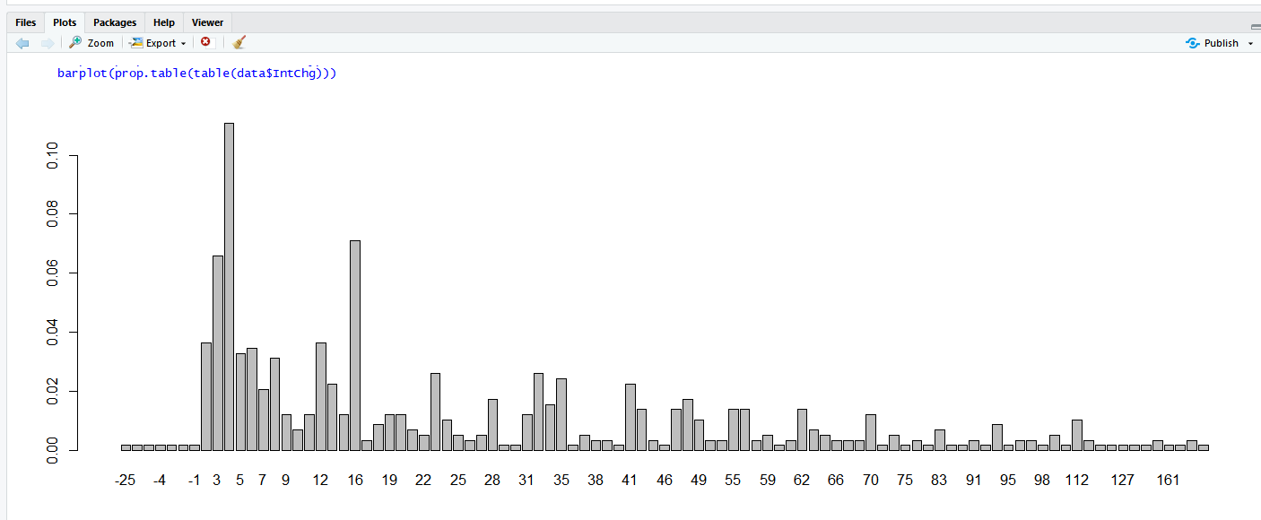

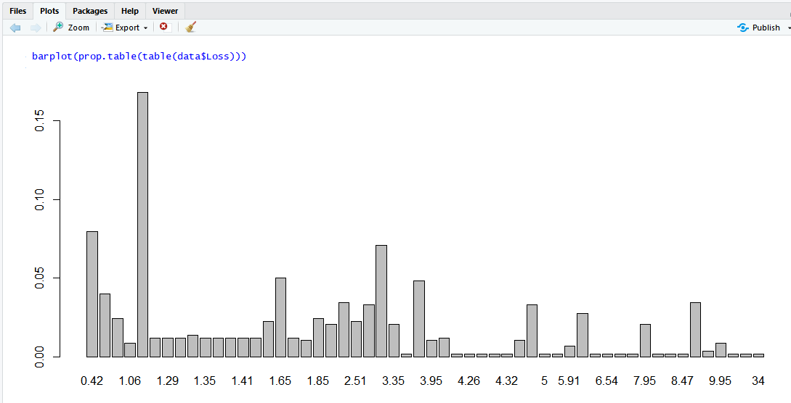

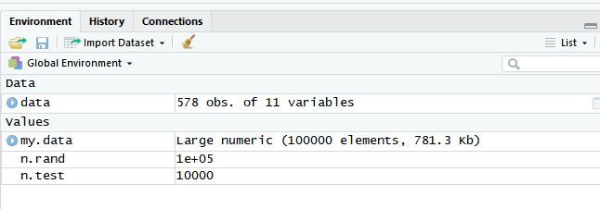

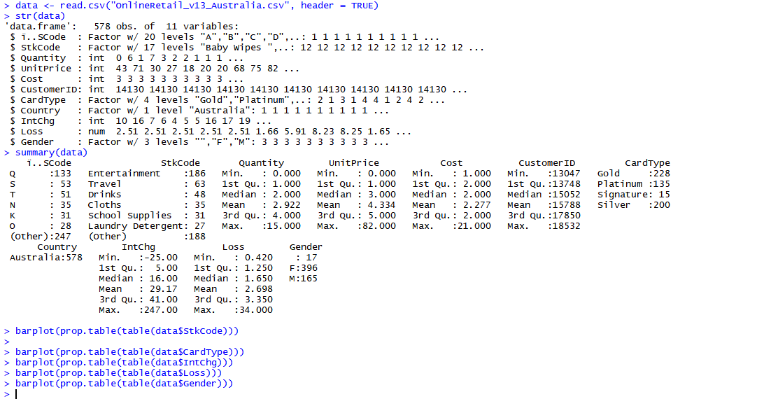

save.image("C:/Users/guest 1/Desktop/DSP Project Workspace/OnlineRetail_v13_Australiav1.rdata.RData")

India

|  |
| --- |
| > data <- read.csv("OnlineRetail_v15_India.csv", header = TRUE)  > str(data)  'data.frame': 563 obs. of 11 variables:  $ ï..SCode : Factor w/ 20 levels "A","B","C","D",..: 1 1 1 1 1 1 1 1 1 1 ...  $ StkCode : Factor w/ 18 levels "Baby Wipes ",..: 13 13 13 13 13 13 13 13 13 13 ...  $ Quantity : int 6 6 8 6 6 2 6 6 6 32 ...  $ UnitPrice : int 3 3 3 3 3 8 4 2 2 2 ...  $ Cost : int 15 20 22 20 20 15 26 11 11 54 ...  $ CustomerID: int 17850 17850 17850 17850 17850 17850 17850 17850 17850 13047 ...  $ CardType : Factor w/ 4 levels "Gold","Platinum",..: 4 3 1 4 1 2 4 2 2 3 ...  $ Country : Factor w/ 1 level "India ": 1 1 1 1 1 1 1 1 1 1 ...  $ IntChg : int 4 5 5 5 5 4 6 3 3 12 ...  $ Loss : int 1 1 1 1 1 1 1 1 1 1 ...  $ Gender : Factor w/ 2 levels "F","M": 1 1 1 1 2 2 2 2 2 2 ...  > barplot(prop.table(table(data$Gender)))                  R-Studio File saved! |
|  |
| |  | | --- | |  | |

Save.image("C:/Users/guest 1/Desktop/DSP Project Workspace/OnlineRetail_v15_India.rdata.RData")